Supplement to: Quantifying Systematic Bias in Observational Causal Estimates Using Negative Controls: The Bias Fraction
Zeng Zhechun, MD, MPH
Wang Jinwen, MD, PhD
Zuo Huijuan, MD, MPH
Shu Lixia, PhD
2026-08-14

eAppendix 1. Detailed Methods

Notation and setting
Consider an observational study estimating the effect of a binary treatment $A$ on an outcome $Y$. The target causal estimand is the average treatment effect on the log relative risk scale, $ψ=log{\text{RR}}_{\text{true}}$. After applying an estimator $\hat{ψ}$ (eg, TMLE with SuperLearner-based nuisance function estimation), we obtain a point estimate ${\hat{ψ}}_{\text{obs}}$ with estimated standard error ${\hat{σ}}_{\text{obs}}$.
In addition to the primary outcome $Y$, the investigator has $K$ negative control outcomes $N_{1},…,N_{K}$. Each negative control $N_{k}$ shares the confounding structure of $Y$, meaning the same set of unmeasured confounders affects both $N_{k}$ and $Y$, but $N_{k}$ is not causally affected by treatment $A$. For each control, the same estimator $\hat{ψ}$ is applied to obtain ${\hat{γ}}_{k}$, the estimated log relative risk associating $A$ with $N_{k}$, along with its standard error ${\hat{τ}}_{k}$.
The key working assumption is shared bias structure (also termed bias exchangeability): conditional on measured covariates, the distribution of residual bias affecting the primary estimate ${\hat{ψ}}_{\text{obs}}$ is approximately the same as the distribution governing the negative control estimates ${\hat{γ}}_{1},…,{\hat{γ}}_{K}$. We use the term bias exchangeability to distinguish this assumption from the standard causal exchangeability assumption (no unmeasured confounding); the two are related but distinct. Under bias exchangeability, the negative controls form a sample from the bias-generating process, allowing empirical estimation of the bias distribution. This assumption, like the no-unmeasured-confounding assumption it is meant to diagnose, cannot be directly verified from the data; its plausibility must be assessed through domain knowledge and sensitivity analyses.

Definition of the credibility metric
Let $μ_{B}$ denote the mean systematic bias. Under the bias exchangeability assumption, $μ_{B}$ can be estimated from the negative controls: ${\hat{μ}}_{B}$ is obtained by fitting an empirical null distribution to $\{({\hat{γ}}_{k},{\hat{τ}}_{k})\}_{k=1}^{K}$¹. The bias-corrected (calibrated) estimate is $\tilde{ψ}={\hat{ψ}}_{\text{obs}}−{\hat{μ}}_{B}$, with calibrated standard error $\tilde{σ}=\sqrt{{\hat{σ}}_{\text{obs}}^{2}+{\hat{σ}}_{B}^{2}}$, where ${\hat{σ}}_{B}$ is the estimated between-control heterogeneity in bias.
$$BF=\frac{|{\hat{μ}}_{B}|}{|{\hat{μ}}_{B}|+|\tilde{ψ}|}=\frac{|{\hat{μ}}_{B}|}{|{\hat{μ}}_{B}|+|{\hat{ψ}}_{\text{obs}}−{\hat{μ}}_{B}|}$$
BF is the share of the total calibrated signal, bias plus residual effect, attributable to systematic bias. It lies in [0,1] by construction; BF = 1 when the calibrated estimate is exactly zero, and BF = 0 when no systematic bias is estimated. The value 0.5 marks equal contributions of bias and residual effect; 1/3 marks a residual effect twice the bias.
Rationale for the bounded form. The ratio form is preferred over a bias difference ($|{\hat{μ}}_{B}|−|\tilde{ψ}|$) because, on the log relative risk scale, it is scale-invariant and directly captures the question of interest: of the signal that survives calibration, how much is bias? The specific choice of denominator, total calibrated signal rather than the residual effect alone, makes the metric bounded. The unbounded bias-effect ratio, $BER=|{\hat{μ}}_{B}|/|\tilde{ψ}|$, carries the same information through $BF=BER/(1+BER)$; the bounded scale avoids the ratio’s instability when the denominator approaches zero and removes the need for special handling of infinite values at the null. We report BER as an auxiliary display.
Observed bias fraction. A companion quantity, the observed bias fraction (OBF), divides the estimated bias by the uncalibrated estimate: $OBF=|{\hat{μ}}_{B}|/|{\hat{ψ}}_{\text{obs}}|$. OBF answers “of the association as estimated before calibration, what share is bias?” In the beta-blocker analysis OBF = 1.03: the estimated bias is comparable to the entire observed association. In the GDMT analysis OBF = 0.44. OBF is descriptive and unbounded; all classifications use BF.
The metric is computed directly from quantities already produced by the OHDSI empirical calibration pipeline^{1,2} using the EmpiricalCalibration R package, and therefore requires no additional data beyond the negative control estimates and the primary estimate.

Confidence interval for BF
A 95% confidence interval for BF is constructed through nonparametric bootstrap with $B=2000$ resamples, as follows. For each iteration $b=1,…,B$: (1) resample the $K$ negative control estimates $\{({\hat{γ}}_{k},{\hat{τ}}_{k})\}$ with replacement; (2) refit the empirical null distribution to obtain ${\hat{μ}}_{B}^{(b)}$ and ${\hat{σ}}_{B}^{(b)}$; (3) compute the bias-corrected estimate ${\tilde{ψ}}^{(b)}={\hat{ψ}}_{\text{obs}}−{\hat{μ}}_{B}^{(b)}$, holding the primary estimate ${\hat{ψ}}_{\text{obs}}$ fixed; (4) compute ${BF}^{(b)}=|{\hat{μ}}_{B}^{(b)}|/(|{\hat{μ}}_{B}^{(b)}|+|{\tilde{ψ}}^{(b)}|)$. The 95% CI is the 2.5th and 97.5th percentiles of $\{{BF}^{(b)}\}$ on the logit scale, back-transformed to [0,1]; equivalently, it is the percentile CI of BER on the log scale, transformed to BF. The point estimate is the bootstrap median on the logit scale, back-transformed, so the point estimate and the CI come from the same distribution. The bootstrap resamples only the negative controls because the dominant source of uncertainty for BF is the estimation of $μ_{B}$ from a finite set of negative controls. As an alternative, Fieller’s theorem provides a closed-form confidence set for the underlying ratio that may offer better coverage when the denominator is near zero³.

Fieller confidence sets
The signed ratio $ρ=μ_{B}/\tilde{ψ}$ underlies BF through $BF=|ρ|/(1+|ρ|)$. With $m_{1}={\hat{μ}}_{B}$, $m_{2}=\tilde{ψ}$, $v_{11}=Var({\hat{μ}}_{B})$, $v_{22}={\hat{σ}}_{\text{obs}}^{2}+v_{11}$, and $v_{12}=−v_{11}$ (the primary estimate is independent of the negative controls), the Fieller set at level $1−α$ contains all $ρ$ satisfying $(m_{1}−ρm_{2})^{2}≤z_{α/2}^{2}(v_{11}−2ρv_{12}+ρ^{2}v_{22})$³. We estimated $v_{11}$ from the variance of ${\hat{μ}}_{B}$ across bootstrap resamples.
For the beta-blocker analysis the set was exterior, $(−∞,−1.62]∪[1.45,∞)$: only ratios inside [-1.62, 1.45] are excluded at 95%. The calibrated estimate ($\tilde{ψ}=0.006$) is tiny relative to its uncertainty, so the ratio is poorly identified in the frequentist sense; the bootstrap CI on BF nevertheless lies entirely above 0.5, and the zone assignment is unaffected. For GDMT the set was interior, [0.42, 1.8], straddling 1, consistent with the mixed classification. When the calibrated estimate is near zero, no interval method can pin down the ratio; readers should rely on the zone assignment from the BF bootstrap CI and on the calibrated p-value.

Relationship to existing approaches
The proposed metric extends empirical calibration^{1,2} by providing a continuous credibility measure alongside the binary calibrated p-value. The calibrated p-value answers “Is there evidence of an effect after accounting for bias?” while the metric answers “What share of the surviving signal is bias, and does enough of an effect remain to be meaningful?”
The E-value⁴ quantifies the minimum strength of unmeasured confounding required to explain away an observed association, a hypothetical sensitivity analysis. The proposed metric, in contrast, is empirically grounded in observed negative control data. The two approaches are complementary: the E-value asks what would need to be true, while the calibration-based metric estimates what the negative controls actually indicate about the bias present in the data.

Estimation procedure
Step 1: Empirical null estimation. Fit the model ${\hat{γ}}_{k}∼N(μ_{B},\sqrt{{\hat{τ}}_{k}^{2}+σ_{B}^{2}})$, $k=1,…,K$, using maximum likelihood as implemented in the fitNull function of the EmpiricalCalibration R package¹. This produces ${\hat{μ}}_{B}$ and ${\hat{σ}}_{B}$.
Step 2: Bias-corrected estimate. Compute $\tilde{ψ}={\hat{ψ}}_{\text{obs}}−{\hat{μ}}_{B}$ with calibrated standard error $\tilde{σ}=\sqrt{{\hat{σ}}_{\text{obs}}^{2}+{\hat{σ}}_{B}^{2}}$.
Step 3: Credibility metric calculation. Compute $BF=|{\hat{μ}}_{B}|/(|{\hat{μ}}_{B}|+|\tilde{ψ}|)$. Obtain a 95% confidence interval using the logit-scale nonparametric bootstrap ($B=2000$).
Consistency property. Under the bias exchangeability assumption and standard regularity conditions, ${\hat{μ}}_{B}$ is consistent for $μ_{B}$ as $K→∞$, and $\tilde{ψ}$ converges in probability to $ψ$. The map $f(μ_{B},ψ)=|μ_{B}|/(|μ_{B}|+|ψ|)$ is continuous at every point of the parameter space, including $ψ=0$, where $f(μ_{B},0)=1$. By the continuous mapping theorem, BF is consistent for the population bias fraction over the whole parameter space, with no exclusion of the null. This contrasts with the unbounded ratio, whose population limit diverges at the null. The denominator of BF is $\tilde{ψ}$, not the true effect $ψ$; the metric does not estimate the true treatment effect.

Threshold asymmetry
The thresholds 1/3 and 0.5 are asymmetric on the logit scale. A symmetric alternative would use 1/3 and 2/3. We adopt the asymmetric design deliberately: in observational research, the cost of a false causal claim exceeds the cost of excessive caution. This conservative asymmetry biases classification toward the bias-dominated zone, which we view as appropriate given the stakes of causal claims from observational data. BF = 1 (calibrated estimate exactly zero) is classified as bias-dominated.

Negative control overlap and cautions
Some negative controls share overlapping outcome definitions: the “infection” category encompasses urinary tract infection and cellulitis as subcategories. This nesting means the 12 controls do not represent 12 fully independent observations, which could lead to underestimation of ${\hat{σ}}_{B}$ and overly narrow bootstrap CIs. The leave-one-out sensitivity analysis provides a partial check: removing any single control, including the nested ones, did not change the qualitative classification. The “fall” outcome warrants caution, as beta-blockers may increase fall risk through bradycardia or orthostatic hypotension, potentially violating the no-causal-effect assumption. However, the observed protective association for falls (RR < 1) is opposite in direction to the expected adverse effect. Confounding thus appears to dominate any causal effect; the leave-one-out analysis confirmed that excluding “fall” did not alter the bias-dominated classification.

eAppendix 2. What BF Does Not Estimate
The metric does not estimate the true treatment effect; it summarizes the relationship between estimated bias and the residual effect after calibration. A bias-dominated classification means “the calibrated estimate does not support a causal claim,” not “the true effect is zero.” The metric also does not identify the source of bias, whether healthy-adherer confounding, indication bias, or other sources of unmeasured confounding. The metric does not provide a probability or posterior distribution over the true effect. When $\tilde{ψ}≈0$, a BF near 1 could reflect either a genuinely null treatment effect or a bias that approximately cancels a non-zero true effect. The metric cannot distinguish these cases.

eAppendix 3. When Calibration-Based Diagnostics Should Not Be Used
Insufficient negative controls. With $K<5$, the empirical null estimate is too imprecise. We recommend at least 8-10 controls with adequate event counts.
Non-exchangeable controls. If negative controls are affected by outcome-specific mechanisms that do not operate on the primary endpoint, the bias distribution will be misleading.
Heterogeneous bias directions. The empirical null model assumes negative controls are affected by bias in the same direction. If controls show bias in opposite directions, ${\hat{μ}}_{B}$ will be attenuated toward zero, producing an overly optimistic BF.
Small residual effects. When the true treatment effect is near zero, the denominator of the underlying ratio is near zero. On the BF scale this appears as values near 1, wide bootstrap CIs, and unbounded Fieller sets. This correctly signals that the calibrated estimate is uninformative; read BF near 1 as signal saturation by bias, not as a precise fraction.

eTable 1. Comparison of BF and Calibrated p-Value
Feature | BF | Calibrated p-value
Output type | Continuous fraction in [0,1] | Binary significance test
Question answered | How large is bias relative to residual effect? | Is there evidence of an effect after bias correction?
Scale | Scale-invariant, bounded | Depends on sample size
Interpretation when non-significant | Distinguishes “bias dominated” from “borderline” | Cannot distinguish these scenarios
Behavior at the null | BF = 1 | p close to 1
Computation | From OHDSI pipeline quantities | From OHDSI pipeline
Recommended use | Alongside calibrated p-value and CI | Current standard

eTable 2. Simulation Study Design
Simulation study design. Total: 7 x 6 x 2 x 2 x 2 = 336 conditions, 200 repetitions each (67,200 total). BF_true values span {0.111, 0.143, 0.200, 0.250, 0.273, 0.333, 0.400, 0.429, 0.500, 0.571, 0.600, 0.667, 0.727, 0.750, 0.800, 0.857, 0.889} plus the null (BF_true = 1). The 30% violation level is implemented as round(K x 0.3) shifted controls, 4/12 = 33.3% for K = 12 and 8/25 = 32.0% for K = 25.
Factor | Levels (count) | N levels
True effect size (psi) | 0, -0.05, -0.10, -0.15, -0.20, -0.30, -0.40 (7) | 7
Systematic bias (mu_B) | -0.05, -0.10, -0.15, -0.20, -0.30, -0.40 (6) | 6
Bias heterogeneity (sigma_B) | 0.05, 0.10 (2) | 2
Number of negative controls (K) | 12, 25 (2) | 2
Exchangeability violation | 0%, 30% (2) | 2

eTable 3. CI-Based Classification Heuristic Results
CI-based classification heuristic vs point-estimate rule across all 336 conditions (67,200 repetitions). The CI-based rule issued a decisive (non-mixed) classification in 47.6% of repetitions; those decisive calls were 86.8% accurate.
Zone | N repetitions | Point-estimate accuracy, % | CI-based accuracy, % | CI classified as mixed, %
Bias-dominated (BF_true > 0.5 or null) | 33600 | 80.3 | 57.5 | 42.0
Mixed (1/3 <= BF_true <= 0.5) | 22400 | 41.8 | 81.9 | 81.9
Effect-dominated (BF_true < 1/3) | 11200 | 95.5 | 75.5 | 24.5
Overall | 67200 | 70.0 | 68.6 | 52.4

eTable 4. Leave-One-Out Sensitivity Analysis
Leave-one-out sensitivity analysis. Full-data BF = 0.91. All 12 exclusions remained in the bias-dominated zone (BF > 0.5).
Excluded negative control | BF | Zone
infection | 0.982 | Bias-dominated
gi_bleed | 0.966 | Bias-dominated
fall | 0.982 | Bias-dominated
uti_only | 0.966 | Bias-dominated
cellulitis | 0.989 | Bias-dominated
cataract | 0.987 | Bias-dominated
osteoarthritis | 0.960 | Bias-dominated
traffic_accident | 0.965 | Bias-dominated
hemorrhoids | 0.961 | Bias-dominated
bph | 0.927 | Bias-dominated
gout | 0.890 | Bias-dominated
tendinitis | 0.983 | Bias-dominated

eTable 5. SuperLearner Sensitivity Analysis
SuperLearner sensitivity analysis. All three configurations remained in the bias-dominated zone with bootstrap CIs entirely above 0.5.
SuperLearner configuration | BF | 95% CI | Zone
SL.glm | 0.901 | [0.748, 0.995] | Bias-dominated
SL.glm + SL.gam | 0.896 | [0.753, 0.995] | Bias-dominated
SL.glm + SL.gam + SL.xgboost | 0.918 | [0.718, 0.995] | Bias-dominated

eTable 6. Grace Period Sensitivity Analysis
Grace period sensitivity analysis. Calibrated risk ratio estimates ranged from 0.995 to 1.049, and all BF estimates remained in the bias-dominated zone (BF > 0.5).
 | Grace period (days) | N (cohort) | Uncalibrated RR | Calibrated RR | BF | Classification
mean | 3 | 14677 | 0.8357 | 1.0110 | 0.9456 | bias-dominated
mean1 | 5 | 14677 | 0.8222 | 0.9948 | 0.9731 | bias-dominated
mean2 | 7 | 14677 | 0.8305 | 1.0048 | 0.9755 | bias-dominated
mean3 | 10 | 14555 | 0.8382 | 1.0141 | 0.9315 | bias-dominated
mean4 | 14 | 14410 | 0.8666 | 1.0485 | 0.8009 | bias-dominated

Completed TARGET 21-item reporting checklist. Abbreviated item wording adapted from the TARGET statement⁵; full wording is available at https://target-guideline.org/.
Section | Item | TARGET checklist item (abbreviated) | Location reported in this manuscript
Abstract | 1a | Identify that the study attempts to emulate a target trial using observational data. State the study objectives and briefly summarize the specified target trial. | Abstract (Objective; Design, Setting, and Participants)
Abstract | 1b | Report the data sources used for emulation. | Abstract (Design, Setting, and Participants)
Abstract | 1c | Summarize key assumptions, statistical methods, findings and conclusions. | Abstract (Methods; Results; Conclusions and Relevance)
Introduction | 2 | Describe the scientific background of the study and the gap in knowledge. | Introduction (paragraphs 1-2)
Introduction | 3 | Summarize the causal question. | Introduction (paragraph 1); Methods (Case study design)
Introduction | 4 | Describe the rationale for emulating a target trial with the available data. Cite randomized trials informing the design of the target trial if applicable. | Introduction; Methods (GDMT known-effect comparison); eTable 8
Methods | 5 | Cite the data sources contributing to the analyses and for each one describe: original purpose, type, geographic locations, setting and time-period. | Methods (Case study design)
Methods | 6a/7a | Eligibility criteria: describe (specification) and operationalize with the data (emulation). | Methods (Case study design); eTable 8
Methods | 6b/7b | Treatment strategies: describe (specification) and operationalize with the data (emulation). | Methods (Case study design); eTable 8
Methods | 6c/7c | Assignment procedures: describe (specification) and operationalize with the data (emulation). | Methods (Case study design); eTable 8
Methods | 6d/7d | Follow-up: describe (specification) and operationalize with the data (emulation). Visual diagram recommended. | Methods (Case study design); eTable 8; eFigure 7
Methods | 6e/7e | Outcomes: describe (specification) and operationalize with the data (emulation). | Methods (Case study design); eTable 8
Methods | 6f/7f | Causal contrasts: describe (specification) and operationalize with the data (emulation). | Methods (The credibility metric); eTable 8
Methods | 6g | Identifying assumptions: describe (specification) and operationalize with the data (emulation), including baseline confounding due to lack of randomization. | Methods (Notation and setting: bias exchangeability); Discussion (Limitations); eTable 8
Methods | 6h | Data analysis plan: describe the data analysis procedures and any associated statistical modelling assumptions, including approaches for handling missing data. | Methods; eTable 8; Supplement (bootstrap and implementation details)
Methods | 6h.ii | Sensitivity analyses to assess the sensitivity of the results to the choice of operationalizations, assumptions and analysis. | Results (Sensitivity analyses; eTables 3-6)
Results | 8 | Report numbers of individuals assessed for eligibility, eligible, and assigned to each treatment strategy. A flow diagram is strongly recommended. | eFigure 7
Results | 9 | Describe the distribution of characteristics of individuals at baseline, by treatment strategy. | eTable 9
Results | 10 | Summarize length of follow-up and describe reasons for end of follow-up for each treatment strategy and causal contrast. | eFigure 7; Methods (Case study design)
Results | 11 | Describe the frequency of missing data in all variables, by treatment strategy when applicable. | eTable 9; Methods (imputation via MICE)
Results | 12 | Describe the frequency or distribution of each outcome, by treatment strategy. | eFigure 7; Results (Calibration results)
Results | 13 | Report the effect estimates for each causal contrast with corresponding measures of precision, including both absolute and relative measures of effect, when applicable. | Results (Tables 1-2; Figures 1-2)
Results | 14 | Report results of all analyses to assess the sensitivity of the estimates to choices in operationalizations, assumptions and analysis. | Results (Sensitivity analyses; eTables 3-6)
Discussion | 15 | Provide an interpretation of the key findings. | Discussion (Principal findings; Clinical interpretation)
Discussion | 16 | Discuss the limitations of the study considering differences between the target trial and its emulation and the plausibility of assumptions, including assumptions regarding baseline confounding due to lack of randomization. | Discussion (Limitations; When calibration-based diagnostics should not be used)
Other information | 17 | Provide the institutional research board or ethics committee that approved the study and approval numbers, if relevant. | Methods (ethics statement)
Other information | 18 | State whether, when and where the study protocol was registered. | eAppendix 5 (not registered; methodological illustration)
Other information | 19 | Provide information on whether data, analytic code and/or other materials are accessible, and where and how they can be accessed. | Data sharing statement; analysis code repository URL
Other information | 20 | Provide the sources of funding and detail the role of the funders in the design, conduct and reporting of the study. | Funding statement
Other information | 21 | State any conflicts of interest and financial disclosures for all authors. | Conflict of interest disclosures

eTable 8. Target trial protocol and observational emulation (TARGET template 1)
Specification of the target trial protocol and its observational emulation, following TARGET template 1. The hypothetical trial and the observational emulation share the same causal estimand; the observational emulation uses an achieved-dose point treatment and adjusts for unmeasured confounding through negative control calibration. eFigure 7 documents the participant flow.
Protocol component | Target trial | Observational emulation
Causal estimand | Log relative risk of 1-year all-cause mortality for adults hospitalized with heart failure, comparing randomization to in-hospital titration to at least 50% of guideline-recommended target beta-blocker dose versus titration to less than 50%, with random assignment and blinding not required of the patient or clinician. | Same estimand, estimated with TMLE⁶ using the Observational Health Data Sciences and Informatics empirical calibration pipeline.
Eligibility criteria | Adults hospitalized with heart failure; contraindications to either strategy (cardiogenic shock, severe bradycardia, high-grade atrioventricular block, eGFR < 15 mL/min/1.73 m^2, prior beta-blocker use within 90 days) excluded. | Operationalized with MIMIC-IV (v2.2) with the ECG extension (v1.0.1)⁷: I50.x diagnosis codes, adults aged 18 years or older, ECG within 48 hours, exclusions above, and survival through the 7-day grace period.
Treatment strategies | Strategy A: titrate to at least 50% of guideline-recommended target beta-blocker dose during the index hospitalization. Strategy B: receive less than 50% of target dose during the index hospitalization. | Operationalized by the maximum prescribed beta-blocker dose as a percentage of the guideline-recommended target dose during the index hospitalization, dichotomized at 50%.
Assignment procedures | Random assignment at baseline, with participants and clinicians aware of allocation. | No randomization; treatment classification based on achieved dose at time zero (end of 7-day grace period). Baseline confounding addressed by TMLE adjustment for 10 covariates and by negative control calibration.
Follow-up | Follow-up from time zero to 1 year or death, whichever occurs first. | Operationalized as the interval days 8 to 365 from admission, with all-cause death ascertained from MIMIC-IV date-of-death records (in-hospital and post-discharge) and survivors administratively censored at 1 year.
Outcome(s) | All-cause mortality within 1 year. | Same endpoint, captured as a binary indicator of death within the follow-up window.
Causal contrast(s) | Intention-to-treat contrast on the log relative risk scale. | Same intention-to-treat-like contrast for a point-treatment strategy classified at time zero; not a per-protocol analysis.
Identifying assumptions | No unmeasured confounding conditional on baseline covariates; consistency; positivity. | Baseline exchangeability conditional on 10 baseline covariates is plausible; bias exchangeability (shared bias structure) is addressed by negative control calibration¹.
Data analysis plan | Log-binomial regression or analogous model with covariate adjustment; sensitivity analyses for unmeasured confounding; prespecified analysis plan. | TMLE with SuperLearner (SL.glm sole learner) for both nuisance models, MICE imputation with 5 datasets, empirical null fitting via EmpiricalCalibration, BF with bootstrap 95% confidence intervals (B = 2000), prespecified sensitivity analyses (leave-one-out negative control, SuperLearner library variation, grace period 3-14 days, GDMT known-effect comparison).

eTable 9. Baseline characteristics of the eligible cohort by treatment strategy
Baseline characteristics of the eligible cohort (n = 14,677) by treatment strategy, drawn from the 10 baseline covariates used in the TMLE adjustment (age, sex, heart rate, QRS duration, QTc interval, atrial fibrillation, left bundle branch block, creatinine, eGFR, potassium) together with additional variables available in MIMIC-IV. Continuous variables are reported as mean (SD); skewed variables (creatinine, troponin T, NT-proBNP) are reported as median [interquartile range]. Categorical variables are reported as n (%). Standardized mean differences (SMDs) compare the two treatment strategies; values below 0.1 indicate adequate balance. Laboratory values with substantial missingness (potassium 72.1%, sodium 95.9%, troponin T 58.9%, NT-proBNP 84.4%, creatinine and eGFR 3.3%, hemoglobin 5.4%) were imputed by multiple imputation by chained equations with 5 datasets for the primary TMLE analysis.
Variable | Overall (N = 14,677) | ≥ 50% target dose (n = 1,772) | < 50% target dose (n = 12,905) | SMD
Age, y | 71.3 (13.6) | 70.0 (12.9) | 71.4 (13.6) | 0.106
Female | 6702 (45.7) | 702 (39.6) | 6000 (46.5) | 0.139
Age ≥ 75 y | 6679 (45.5) | 719 (40.6) | 5960 (46.2) | 0.113
Heart rate, bpm | 79.9 (18.2) | 81.5 (17.9) | 79.7 (18.2) | 0.103
QRS duration, ms | 106.7 (25.6) | 108.9 (26.2) | 106.4 (25.5) | 0.096
QTc interval (Bazett), ms | 458.7 (29.6) | 463.5 (28.2) | 458.1 (29.7) | 0.189
Atrial fibrillation | 4836 (32.9) | 684 (38.6) | 4152 (32.2) | 0.135
Left bundle branch block | 1060 (7.2) | 160 (9.0) | 900 (7.0) | 0.076
Creatinine, mg/dL | 1.1 [0.8, 1.5] | 1.2 [0.9, 1.7] | 1.1 [0.8, 1.5] | 0.142
eGFR, mL/min/1.73 m² | 59.9 (28.3) | 56.4 (28.0) | 60.4 (28.4) | 0.142
eGFR < 60 mL/min/1.73 m² | 7156 (50.4) | 975 (55.4) | 6181 (49.7) | 0.114
Potassium, mEq/L | 4.2 (0.6) | 4.3 (0.7) | 4.2 (0.6) | 0.142
Sodium, mEq/L | 112.0 (2.3) | 112.1 (2.4) | 112.0 (2.3) | 0.067
Hemoglobin, g/dL | 10.8 (1.9) | 11.1 (2.0) | 10.8 (1.9) | 0.199
Troponin T, ng/mL | 0.1 [0.0, 0.4] | 0.1 [0.0, 0.6] | 0.1 [0.0, 0.4] | 0.038
NT-proBNP, pg/mL | 3680.0 [1403.5, 9184.0] | 3409.5 [1470.2, 7941.5] | 3718.0 [1390.0, 9329.0] | 0.080
ECGs during index stay, No. | 2.8 (2.0) | 3.1 (2.1) | 2.7 (1.9) | 0.193
```

eFigure 1. Directed Acyclic Graph of Shared Bias Structure
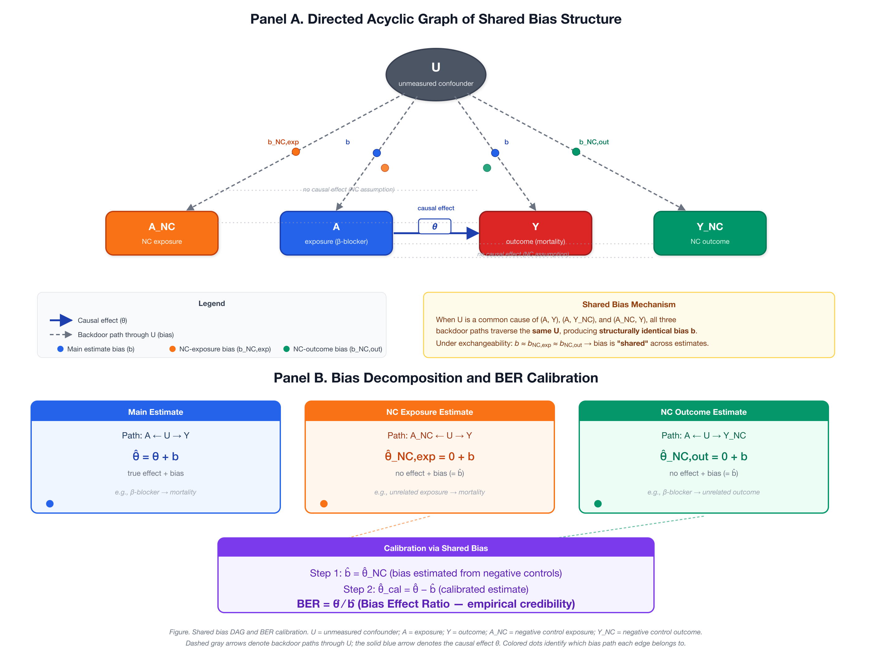
eFigure 1. Directed acyclic graph of shared bias structure and BF calibration. Panel A: U = unmeasured confounder; A = exposure (beta-blocker); Y = primary outcome (mortality); N_k = negative control outcomes. Solid arrows denote causal paths; dashed arrows denote bias paths shared between Y and N_k through U. Panel B: bias decomposition and the BF formula.

eFigure 2. Simulation Classification Accuracy Heatmap
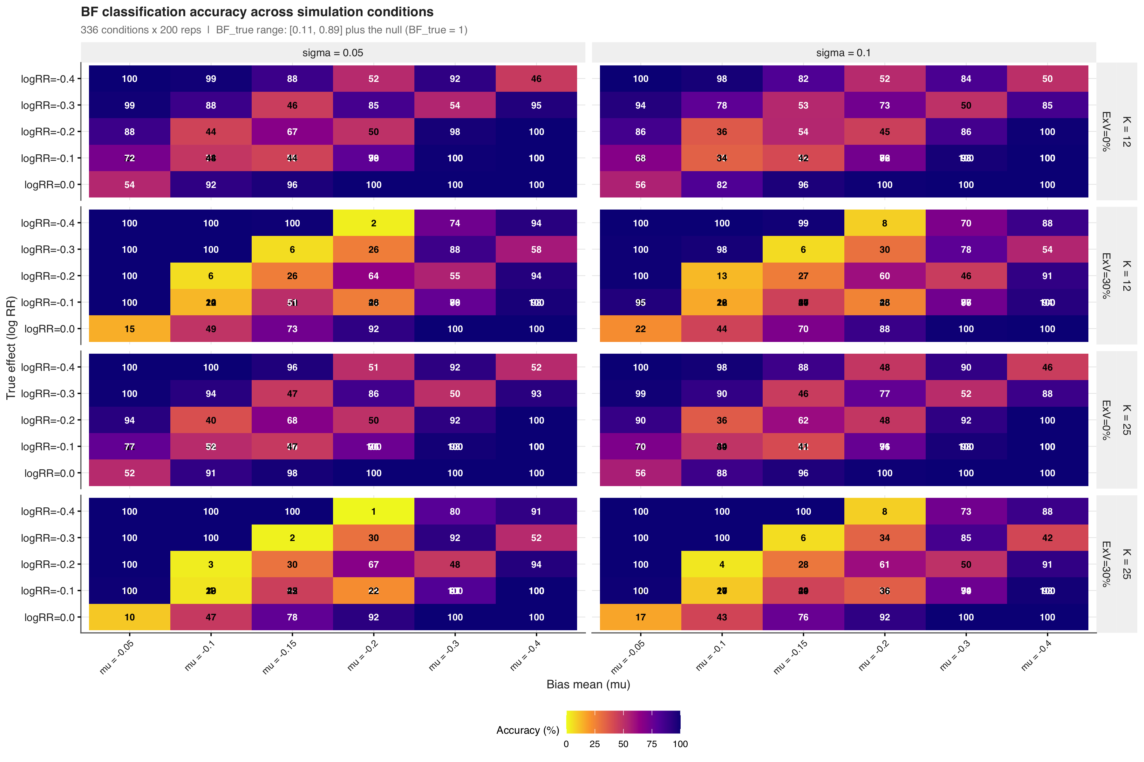
eFigure 2. Classification accuracy across 336 simulation conditions. Each cell shows the accuracy for one combination of true effect size (psi), systematic bias mean (mu_B), bias heterogeneity (sigma_B), negative control count (K), and exchangeability violation level. Darker colors indicate higher accuracy.

eFigure 3. Classification Performance by Zone
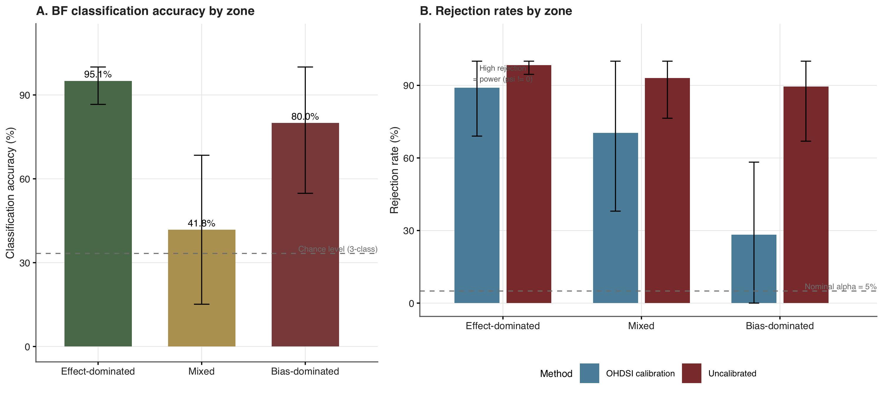
eFigure 3. Classification performance by zone. Panel A: BF classification accuracy by zone with the 33% chance-level reference line. Panel B: OHDSI calibrated p-value rejection rate and uncalibrated rejection rate by zone, with the 5% nominal alpha reference line.

eFigure 4. Leave-One-Out Sensitivity Analysis
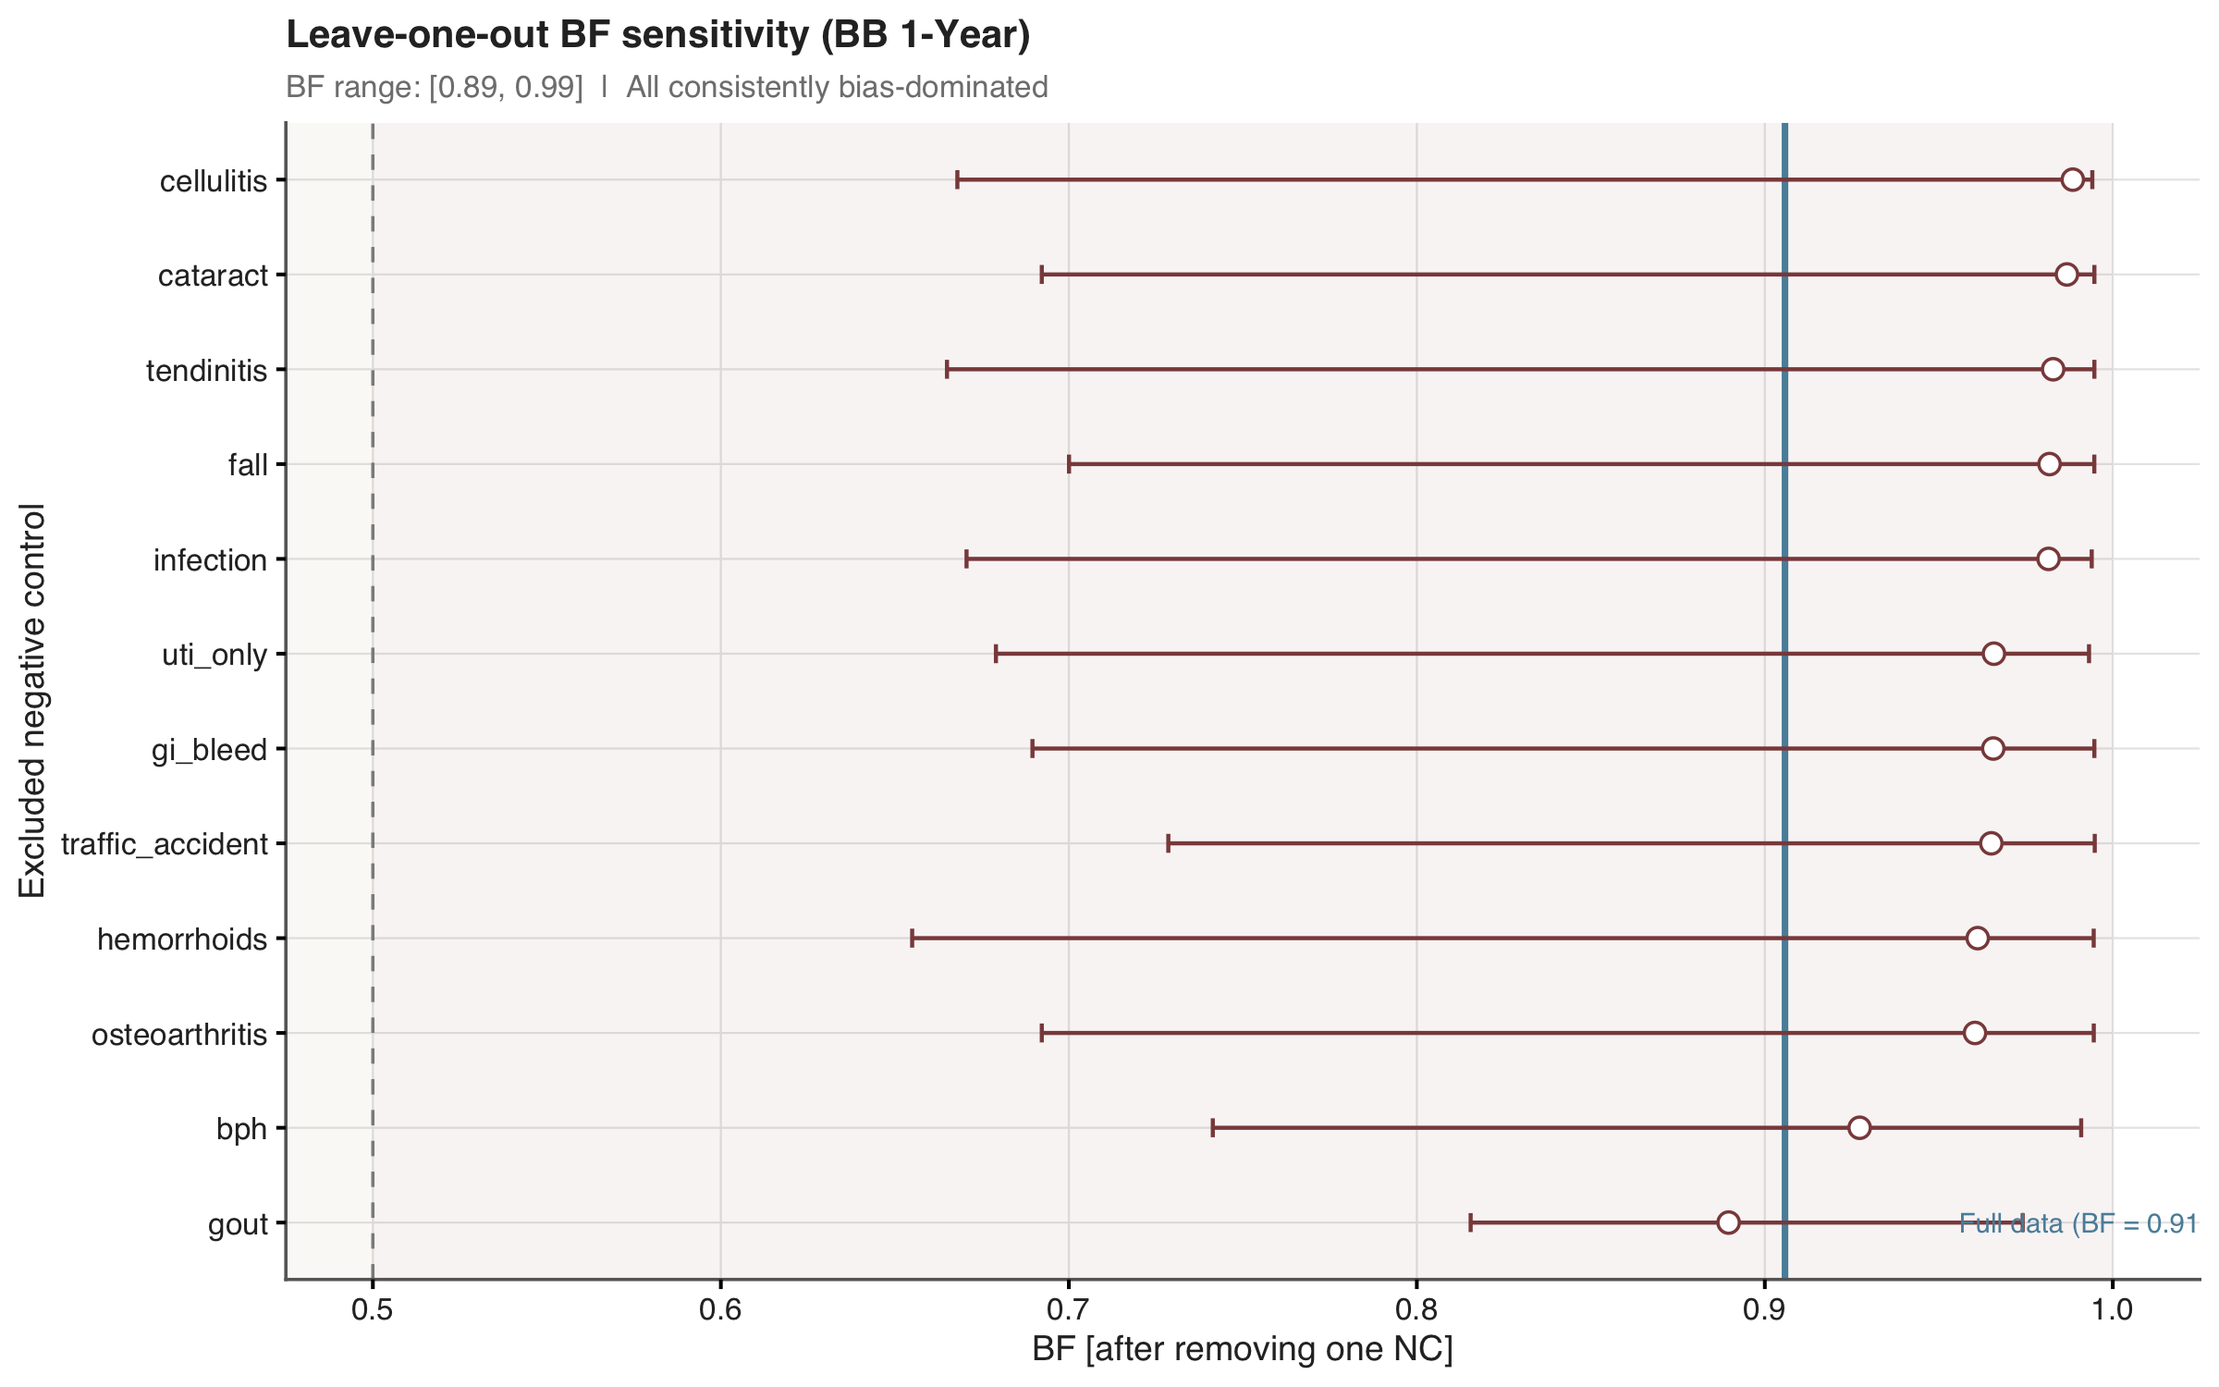
eFigure 4. Leave-one-out sensitivity analysis. Each point shows BF after excluding one negative control. The blue line indicates the full-data BF. All exclusions remained in the bias-dominated zone (BF > 0.5).

eFigure 5. Negative Control Diagnostics
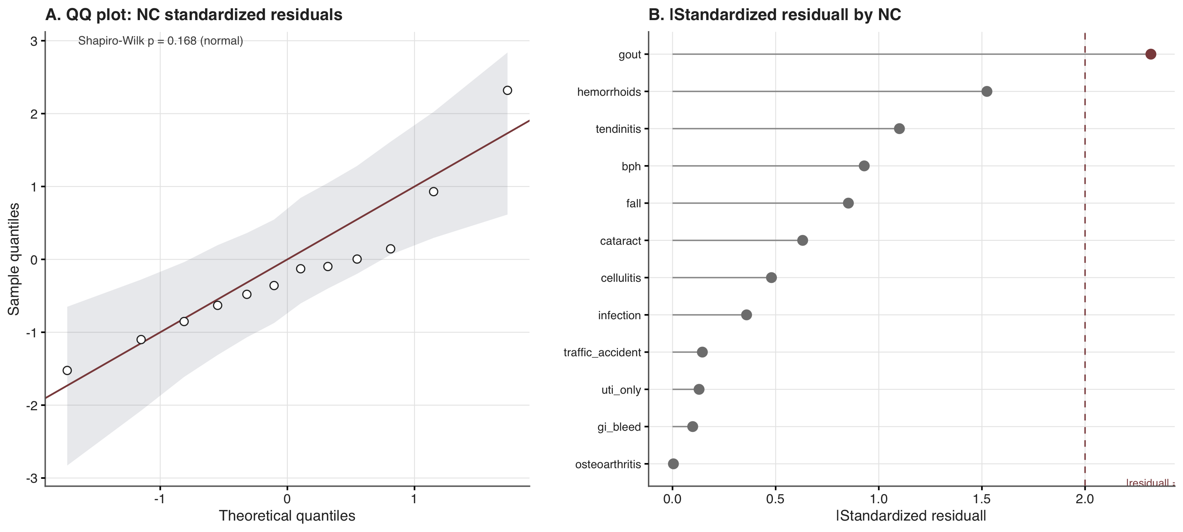
eFigure 5. Negative control diagnostics. Panel A: QQ plot of standardized residuals with simulated 95% confidence envelope. Panel B: lollipop chart of absolute standardized residuals by negative control outcome.

eFigure 6. Bootstrap Distributions (BF scale)
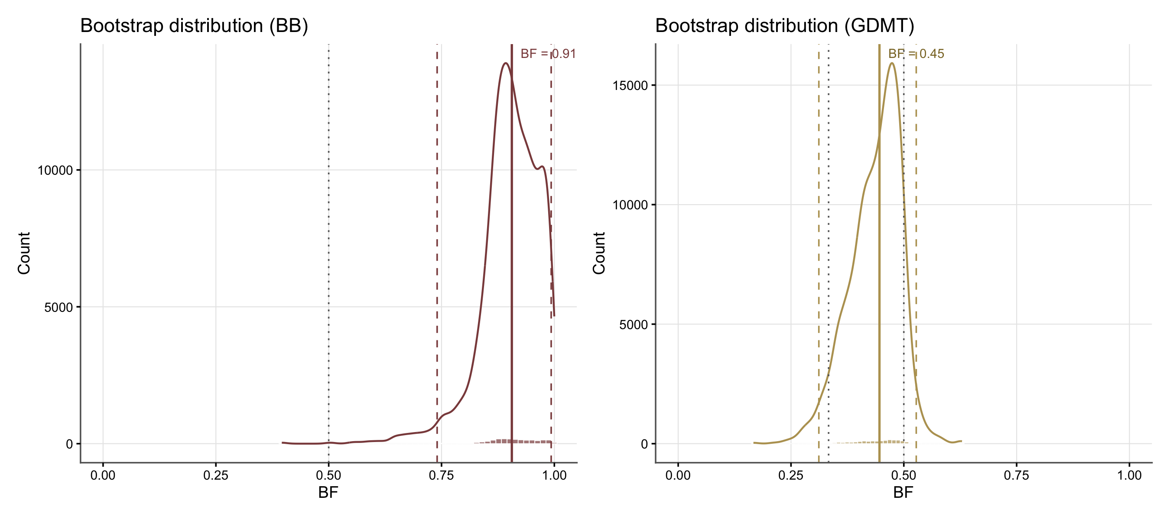
eFigure 6. Bootstrap distributions of BF for beta-blocker (left) and GDMT (right). Solid lines indicate point estimates (bootstrap medians); dashed lines indicate 95% bootstrap CI bounds. Dotted lines mark the zone boundaries at 1/3 and 0.5.

eFigure 7. Participant flow diagram for the target trial emulation
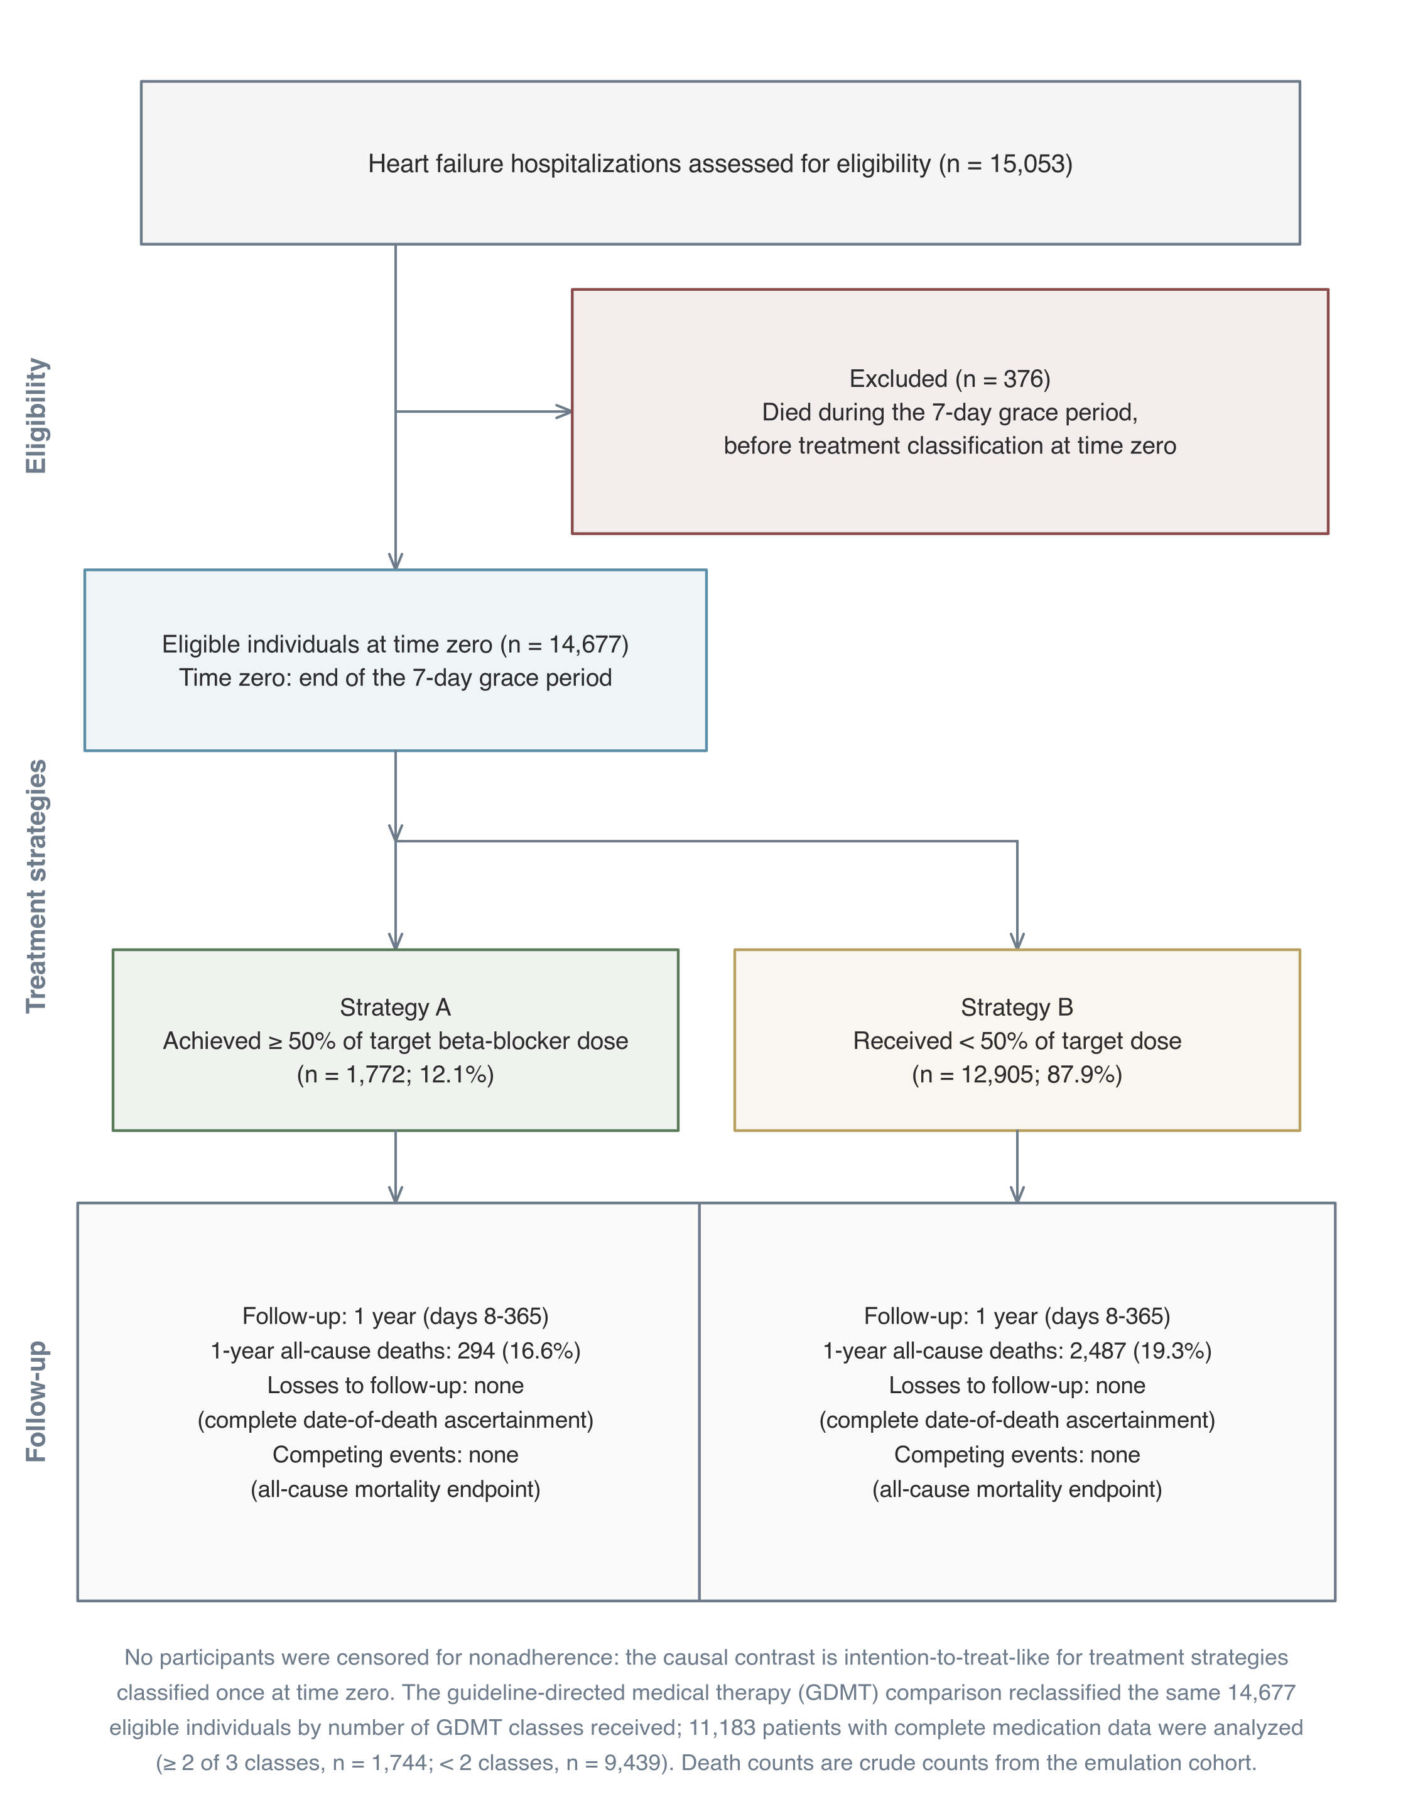
eFigure 7. Participant flow diagram for the target trial emulation, following the TARGET guideline flow diagram template for emulations with a unique time of eligibility and treatment strategies distinguishable at baseline⁵. Time zero is the end of the 7-day grace period. Follow-up covers days 8 to 365. No participants were censored for nonadherence because the causal contrast is intention-to-treat-like for treatment strategies classified once at time zero. The guideline-directed medical therapy (GDMT) comparison reclassified the same 14,677 eligible individuals by number of GDMT classes received; 11,183 patients with complete medication data were analyzed (>= 2 of 3 classes, n = 1,744; < 2 classes, n = 9,439). Death counts are crude counts from the emulation cohort.

eAppendix 4. RECORD-PE Reporting Checklist
The study is reported following the RECORD-PE (REporting of studies Conducted using Observational Routinely-collected health Data for Pharmacoepidemiology) guidelines⁸. The completed checklist is available from the authors upon request.

eAppendix 5. TARGET Trial Emulation Checklist
The target trial emulation is reported following the TARGET (Transparent Reporting of Observational Studies Emulating a Target Trial) statement, published simultaneously in JAMA and BMJ in 2025⁵. The TARGET guideline organizes 21 reporting items into six sections (abstract, introduction, methods, results, discussion, other information) and is supplemented by template 1 for the target trial protocol and its observational emulation and by a flow diagram template for emulations with a unique time of eligibility and treatment strategies distinguishable at baseline. The completed 21-item checklist is provided in eTable 7, the target trial protocol and observational emulation in eTable 8, baseline characteristics by treatment strategy in eTable 9, and the participant flow diagram in eFigure 7. The emulation was not prospectively registered because it is a methodological illustration.

eReferences
1. Schuemie MJ, Ryan PB, DuMouchel W, Suchard MA, Madigan D. Interpreting observational studies: Why empirical calibration is needed to correct p-values. Statistics in Medicine. 2014;33(2):209-218. doi:10.1002/sim.5925
2. Schuemie MJ, Hripcsak G, Ryan PB, Madigan D, Suchard MA. Empirical confidence interval calibration for population-level effect estimation studies in observational healthcare data. Proceedings of the National Academy of Sciences. 2018;115(11):2571-2577. doi:10.1073/pnas.1708282114
3. Fieller EC. Some problems in interval estimation. Journal of the Royal Statistical Society: Series B. 1954;16(2):175-185. doi:10.1111/j.2517-6161.1954.tb00159.x
4. VanderWeele TJ, Ding P. Sensitivity Analysis in Observational Research: Introducing the E-Value. Annals of Internal Medicine. 2017;167(4):268-274. doi:10.7326/M16-2607
5. Cashin AG, Hansford HJ, Hernán MA, et al. Transparent reporting of observational studies emulating a target trial: The TARGET statement. JAMA. 2025;334(12):1084-1093. doi:10.1001/jama.2025.13350
6. Laan MJ van der, Gruber S. Targeted minimum loss based estimation of causal effects of multiple time point interventions. The International Journal of Biostatistics. 2012;8(1). doi:10.1515/1557-4679.1370
7. Johnson AEW, Bulgarelli L, Shen L, et al. MIMIC-IV, a freely accessible electronic health record dataset. Scientific Data. 2023;10(1):1. doi:10.1038/s41597-022-01899-x
8. Langan SM, Schmidt SAJ, Wing K, et al. The reporting of studies conducted using observational routinely collected health data statement for pharmacoepidemiology (RECORD-PE). BMJ. 2018;363:k3532. doi:10.1136/bmj.k3532

